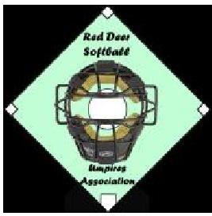 | 2020 INFORMATION FORM  FOR NEW UMPIRES

Name:
Gender:
Address:
City/Town:
Postal Code:
Home Phone:
Work Phone:
Cell Phone:
Email:
Birth Date:

Your Home minor softball association:
(This information will be used for confirming with the association if you are eligible to have your umpire registration fee reimbursed.)
PARENT/GUARDIAN INFORMATION:
if umpire is under 18 years, parent/ guardian please fill in the Information below. Provide
phone number(s) and email address if different than above.

Name:
Home Phone:
Work Phone:
Cell Phone:
Email:
Please email the completed form to:
Pat O’Callaghan, Mentorship and Website, pdoc@shaw.ca or info@rdsua.ca

